4. Risk Management Plan

Risk management refer to the process of identifying, assessing and controlling those risks to minimize the threats that can negatively impact the project plan. Besides, risks are characterized by the level of impact and the chances of it happening in the future.

**Project Risks**

Firstly, project risk is the first categories as they are risks that threaten the project plan. For example, when developing a feature, both members may come up with different design due to the lack of communication. As a result, communication can become an issue between the team members. Also, another project risk also can be the lack of manpower due to unforeseen circumstances such team member may be sick. As a result, the deadline will need to be extended or other members need to takeover and this would affect the rest of the project schedule.

Besides, technical risk is another category which refer to risk that can affect the quality and the timeliness of the software that is being produced. For example, initially the requirements from the team is to complete on five features only. However, after gaining feedback from sponsor or customer. As a result, they would need to refine their requirements due to more features needed to be implement. Thus, depending on the technical skills of the team members, they might not be able to meet the response of the changing requirements. By doing so, the quality of the software may not be as intended and there is higher probability that the deadline will need to be extended as they are not able to produce the software on time.

Lastly, business risk are risks that threaten whether the software will be used depending on how the company market the software. For example, even if the company produce one of the best software that is available on the market. However, due to poor marketing from the marketing team such as not advertising enough. As a result, no one will ever know about this software and the company will experience loss rather than profit.

**Strategies of Risk Management**

Firstly, risk avoidance can be used to avoid any project risk such as software being buggy. For example, before the team start the project, they would have to research and use software that is consistently update because if they were to use an old software, chances of the software being buggy is high. As a result, if the old software were to crash then they would have to redo all their work again. Thus, risk avoidance such as using a more updated software can help to solve project risk.

Besides, risk mitigation which refers to taking actions to reduce negativity of the risk can be used to help reduce technical risk. For example, after the team has finished integrating all their features and components into the system. They would need ensure to do unit testing such as sending out the prototype for the public to use. By doing so, they can gain feedback on what are the bugs that they need to fixed. As a result, when the software is released onto market, the chances of the software being well reviewed is much higher.

Lastly, risk contingency which refers to a plan devised for an outcome that is unexpected such as a backup plan and this can help to reduce business risk. For example, the marketing team needs to ensure that multiple plans when marketing their products such as if promoting the products on platform such as television does not work then another plan for can be used to promote on social media. As a result, this can help to reduce the chances of the product not selling as they are other plans available for it.

2. Roles and Responsibilities

**Kenji**

* Plan initial and next iteration
* Monitor and Manage any changes
* Design Login, Register and Update Profile Page
* Develop Login, Retrieve Hotel Lost, Book and Create Hotel functionality
* Design Database for Administrator
* Define Evaluation Objective and approach for Unit Testing
* Plan on how to integrate the components into the system
* Refine and Integrate into system

**Jia Cheng**

* Design Home, Hotel List and Details Page
* Design Database for Staff
* Develop Register, Rating and Payment Module
* Help in Unit Testing
* Help to refine and integrate into the system

**Mao Cheng**

* Design Reviews, Checkout and Contact Us Page
* Design database for Customer and Hotel Information
* Develop Update Profile for customer and Hotel, Delete and a review section for customer
* Help in Unit Testing and refining the requirements

Project Schedule

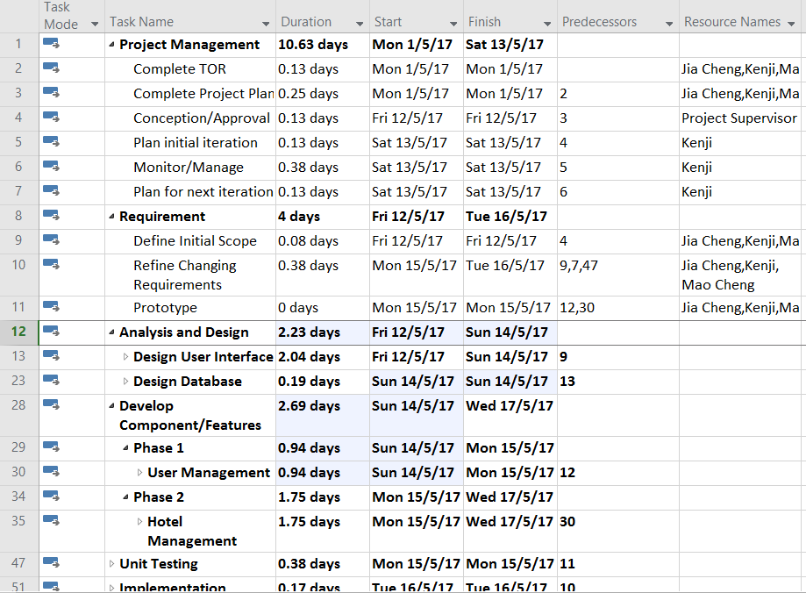

As shown above, upon approval, our team has decided to develop the hotel management software in different phases or iteration. Firstly, as the project I have come up with initial iteration which is to complete our user management section which includes Login, Logout, Register and Update Profile first. During the process, I will monitor and manage any changes required for the requirements. After consulting with the team members, we have agreed with the initial iteration.

The first iteration includes firstly; we would need to design the user interface and database. Next, each of do one of the feature for user management. After that the prototype will then be developed, where we will then send for unit testing for feedback. Lastly, we will refine the requirement and then implement it into the system.

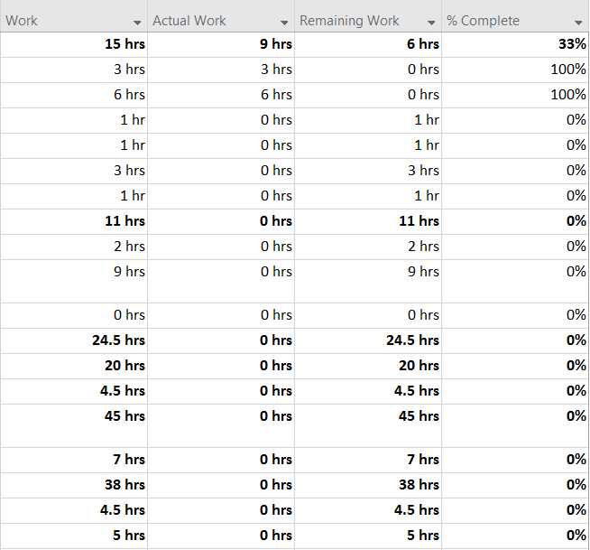

As shown above, the first iteration will be completed on the 16/5/2017, which gives us around three weeks left for the second phase or iteration which is to develop the hotel management features.

Besides, as shown above, I also included another section such as Work, Actual Work, Remaining Work and number of percent completed. This is because we do not spend 24 hours fully for our task. For example, after they are done, then they include it into Action Work where it will then calculate the estimate of work left for each task. Thus, the work tab is there for the members to estimate how long they need to finish their work.

References

<http://www.projectconnections.com/knowhow/burning-questions/difference-between-project-technical-risk.html>